Text-mining Assignment Submission Cover Sheet

Assignment Title | DATA 9900 - Data Mining – Final Assignment
Module
Student Name

Data Understanding and Preparation (20 points)
- Definition of Problem
Identify Negative feedback which can be used to improve services and offerings, and also Identify Positive feedback on products and services so we can enhance offerings and provide more targeted use of marketing budget.

Th data set was sourced from Kaggle - dataset - Kaggle - McDonalds reviews - https://www.kaggle.com/datasets/nelgiriyewithana/mcdonalds-store-reviews
- Data Preparation
Include details of any data cleaning, transformations, data enrichment, feature engineering, feature reduction, etc

    - Data shape = (33,396, 10) > 33, 396 rows of data and 10 columns, parameter variables
    - Column analysis
  - 'reviewer_id'
    - dtype = int - numeric, unique ID, primary key
    - discrete data
  - store_name
    - dtype = python object - str class - text, no variation in data.
    - categorical data
    - 71 rows with non ascii character present, same type for each row = ["McDonald's" "ýýýMcDonald's"]
    - we will fix this.
    - column data won't hold much value in later analysis work as contains no variation.
  - ‘store_address’
    - dtype = python object - str class - alpha numeric, need to split out
    - categorical data
    - 1 non-ascii characters present -
    - 660 rows with non ascii character, same type for each row = '2476 Kalï¿½ï¿½ï¿½ï¿½ï¿½ï¿½ï¿½ï¿½ï¿½ï¿½ï¿½ï¿½ï¿...''
    - will not modify as will address with 'store_id' solution
  - 'category'
    - dtype = python object - str class - text, no variation in data.
    - categorical data
    - of the type of restaurant
    - only 1 type, ["Fast food restaurant"]
    - again, column won't hold much value in later analysis work as contains no variation.
  - 'latitude' -
    - dtype = float - numeric (decimal, pos and neg)
    - continous data
    - may be useful later for spatial analysis if possible
  - 'longtitude'
    - dtype = float - numeric (decimal, pos and neg)
    - continuos data
    - may be useful later for spatial analysis if possible
  - 'ratings_count'
    - dtype = python object - str class - numeric
    - discrete data
    - number of reviews per store at the time the particular review we have in our data was posted,
    - have a lot of repeated values as the number remained the same when review was posted.
    - there are 51 unique values but there are only 40 stores.
    - Not sure how reliable a metric this is ...
  - 'review'
    - dtype = python object - text based content, str type.
    - unstructured data
    - contains actual review text for the store
    - All appears to be english langauge
    - Non-ascii chracters present, many differnt types
    - 3037 rows containing some form of non-ascii character.
    - Some appear to be apostrophes i.e. 'Didnï¿½ï¿½ï¿ïï¿½...'', 'McDonaldï¿½ï¿½ï¿½½ï¿...'', 'Doesnï¿½ï¿½ï¿½ï¿½ï¿½ï¿½ï' and thus retain meaning
    - as such we will not modify or tr fix. wil leave as is and preserve meaning as is.
    - onw row contains '?' character as placeholder value. This adds no data/meaning to dataset. ASs such will remove this row as is just noise.
  - 'rating'
    - dtype - python object - alphanumeric content
    - categorical - ordinal data
    - contains numerical star rating for the store
    - will strip out rating number to separate standalone column , 'star_rating_num' so can use more easily.
    - Missing Values
    - Present in Longitude and Latitude columns only
  - 660 in each
    - No Duplicate entries
    - No ‘null,’, ‘unknown’, 'na’, ‘none’, present in the data.
    - 40 different store addresses
    - Reviewers
  - 33,396 unique users
  - 22,285 unique rows of feedback.
  - Either some reviewers left no feedback or we have identical/near identical feedback.
  - Requires further analysis
    - Numerical Data
  - Is spatial data and unique user IDs.
  - of limited use for analysis directly at this stage
    - Encoding issue:
  - tried different coding types during import of csv data i.e. 'utf-8', 'latin1', 'cp1252'
  - none addressed corrupt characters issue identified earlier i.e. many character types 'ï¿½' among others
  - Ended up using 'ISO-8859-1' so could import without error and not lose amy more data
  - This is most likely due to incorrect encoding used during initial scraping, storage or transfer of data to csv. Unable to recover original characters.
  - Will leave as is to preserve review text meaning as is.

    - Actions:
  - 'review_time'
    - mixture of alpha numeric data and mixture of relative timelines ie.. '23 Hours ago', '1 day ago', '6 months aga', '10 years ago'
    - We have data from < 1 day ago to 10 years + ago. These do not have the same validity and as such need to categorise to be able to easily identify and distinguish data relevance.
  - 'rating'
    - mixture of alphanumeric data i.e. '1 star', '2 star', etc
    - create numeric only rating so can more easily manipulate, count, aggregate etc
  - 'store_address'
    - Split out Address into its component parts, allow us more easily manipulate, aggregate and display, i.e. categorise per state, etc
    - ‘street_number’, ‘street_name’, ‘city’, ‘state’, ‘zip_code’, ‘country’
  - 'store_address'
    - Create unique 'store_id'
    - plots of stores are very busy as the store_address is long mixed string,
    - create a unique ID for each store which will be easier to display during plotting and aggregate, groupbyy later if we need.
    - ‘reviewer_id’ will remain primary key in the data, as it is unique per row, so we have per row reviewer feedback
  - 'store_name'
    - fix single cell corruption
  - 'review'
    - remove row containing just the '?' character as a review. It is placeholder review, contains no data, only noise in our dataset.
- Post cleaning exploration state
  - Shape = 33,395, 19)
  - New derived columns
    - ‘review_relative_time’ - derived relative time column per review
    - ‘store_id’ – unique store if value - per store
    - ‘star_rating_num’ – derived – numeric only value of rating
    - ‘street_number’ - derived from address
    - ‘street_name’- derived from address
    - ‘city’- derived from address
    - ‘state’- derived from address
    - ‘zip_code’- derived from address
    - ‘country’- derived from address
- Missing data
  - total = 4330
  - is consistent with the data we obtained originally in the csv and tied into store details, lat, long, ciy, state, zip_codes and street number with 1030.
  - No missing ‘review’ data
  - No random missing values

2. Data Visualization and Exploration (20 points)
- Data Exploration & Descriptive Analytics
Part 1) Number of stores per state.
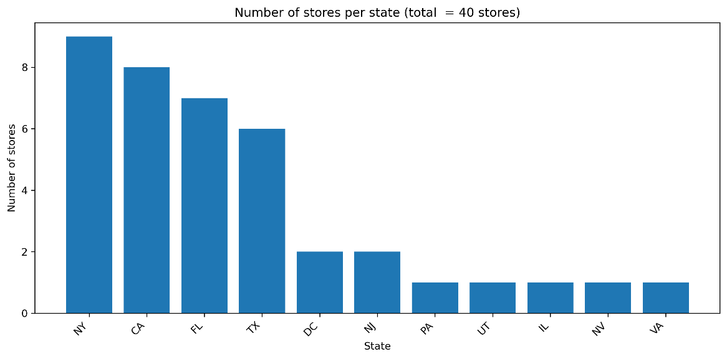
Part 2) Store performance by mean, median and cumulative data
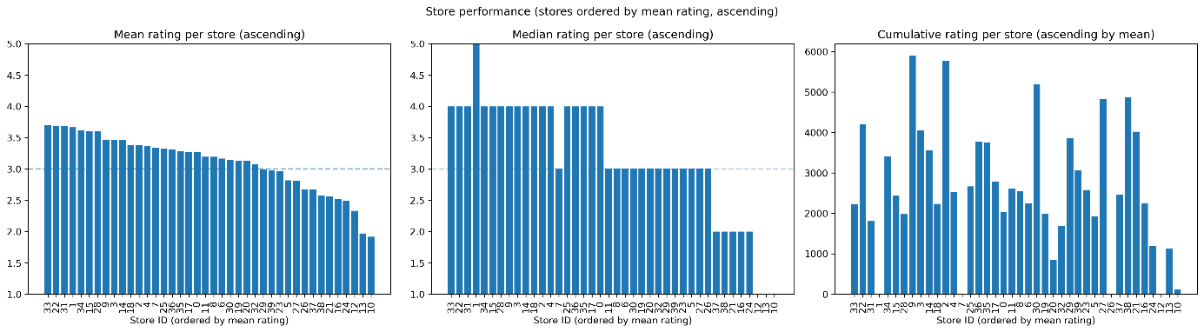
- A quick overview comparison plot of all three, mean, median and cumulative
- store_id numbers - 31, 32, 31 are best performing, agrees broadly across mean and median
- Does not agree with cumulative however.
- Low sample count results in low rating performance. Perhaps put in place a metric for minimum number of reviews.
- Mean appears to provide a more stable calculation of performance. It takes account of all data and addresses variations due to sample size.
- Median provides a stable overview but appears less sensitive to gradual shifts in ratings, and a lot appear neutral at 3, or one step above or below. It displays more step wise behaviour.

Part 3) Tabular comparison of to 5 stores and worst 5 stores
- ======= top 5 stores ==============

- top 5 stores = mean_rating median_rating review_count cumulative_rating
- store_id
- 33 3.70 4.0 602 2226
- 22 3.69 4.0 1140 4209
- 31 3.69 4.0 490 1807
- 1 3.67 5.0 3 11
- 34 3.62 4.0 943 3409
- ======= worst 5 stores ==============

- top 5 stores = mean_rating median_rating review_count cumulative_rating
- store_id
- 10 1.92 1.0 60 115
- 13 1.97 1.0 570 1124
- 12 2.33 1.0 3 7
- 24 2.49 2.0 481 1199
- 16 2.53 2.0 890 2248
- Overview of Results
- 33, 22, an 34 are performing well. Have relatively high rating count and above average rating numbers.
- 13, 16 and 24 are not performing well. Have relatively high rating count yet low mean_rating
- Store 10 haas a relatively low rating count, so more dat would be required to make a proper assessment of it, but initial feedback indicators are that it is not performing to a high level
- stores 1 and 12 have very low sample count, so this result unreliable for those stores
- As per earlier, low sample counts are affecting performance assessment.
Part 4) Number of Reviews per store
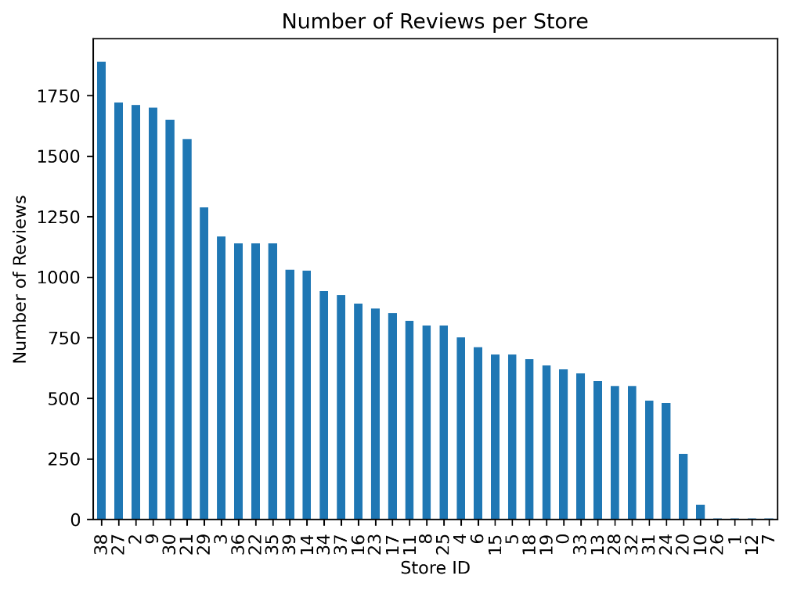
- Bg difference in volume of reviews per store ranging from 1750+ to 1.
- A store with an average rating of 3.5 and 500 reviews has less weight as an accurate measure to a store with an average of 3.1 and 1500 reviews.
Part 5) Yearly rating trends for ratings and review volume
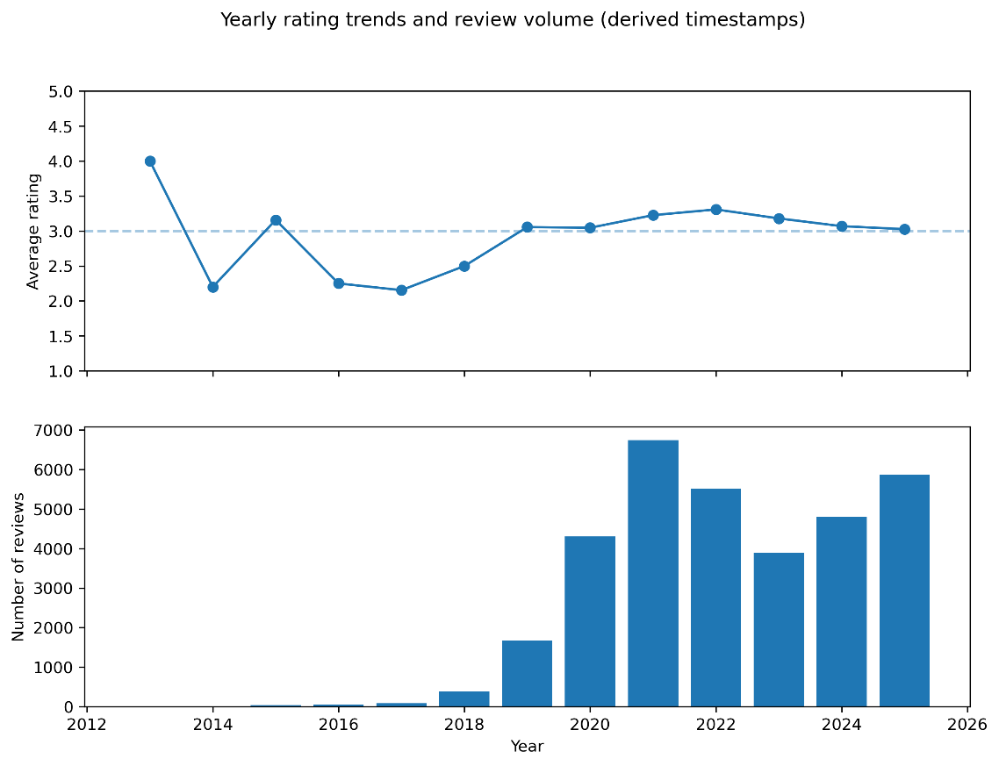
- Average rating dropped from approx 2017 to 2019- but these have low sample counts.
- Has hovered in or around neutral, i.e. 3.0 since then
- Additional time series plots were removed from the notebook as there were limitations in there usefulness.
- These derived time values have their limitations and have accumulations of data around specific dates i.e. Dec every year dure to how we calculated the time.
- we will not focus on time based data for further analyse as a result as limited data available and insight available from it.
- from 2012 to 2019 have very little review data
- Most data is from 2020 onwards
- Feedback volume is skewed to the right (positively skewed)
Par 6) Likert plot of customer ratings by store
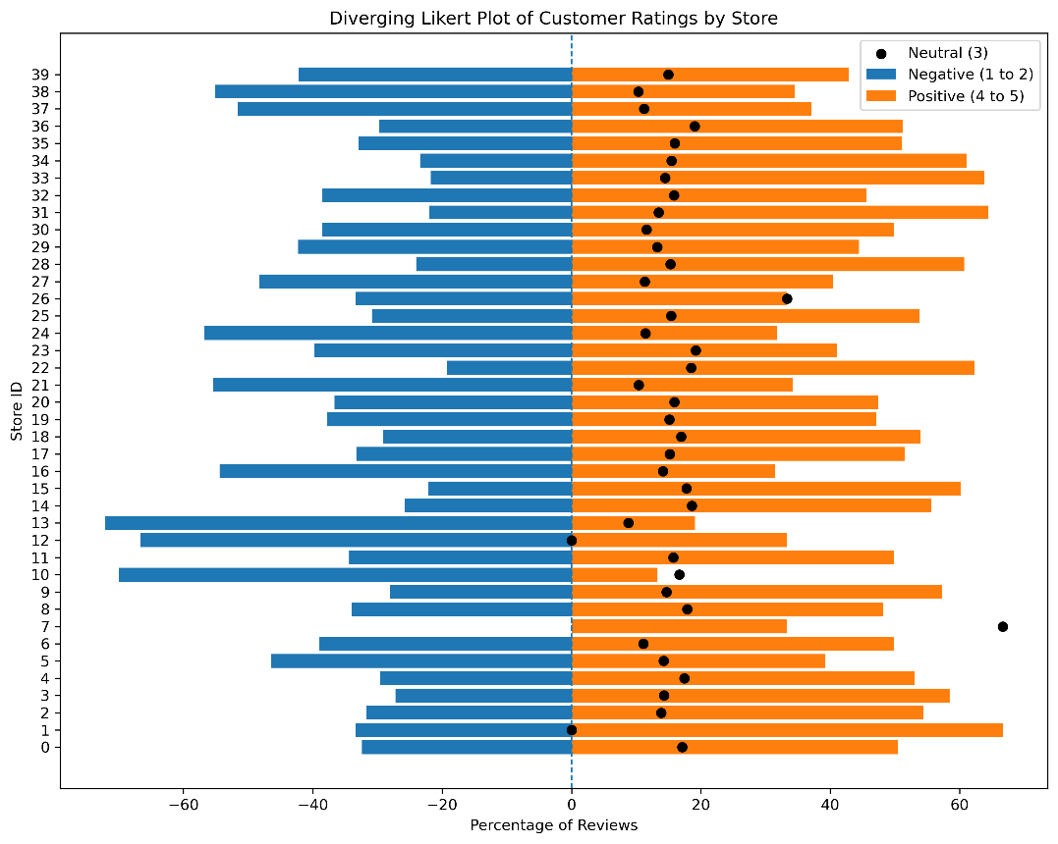
- Diverging Likert plot helps visualise the distribution of positive, negative and neutral reviews to provide an overall sentiment per store.
- Rating values were aggregated at 1+2 = negative, 4+5 as positive and 3 = neutral.
- Orange bars to the right hand side are positive review
- Blue bars to the left hand side are negative reviews
- Black dots on bar are number of neutral reviews
- ‘store_id’ = 7 - looks like anomaly
      - has 0 negative / 2 neutral / 1 positive review = > as total pos/neg/neutral must = 100% = > neutral = 66.6%
      - this is a result of a small sample size.
- Plot provides more direct and complete performance rating in comparison to performance rating using mean, median or cumulative
Part 7) Wordcloud of word frequency
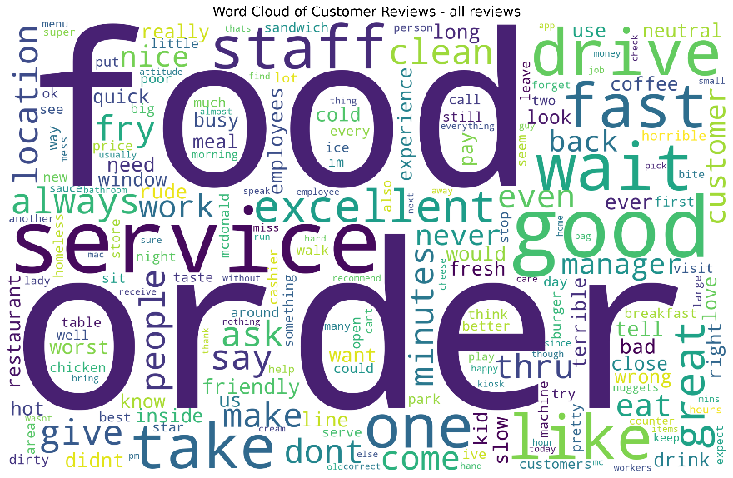

- count of frequencies of words present gives us bag of words
- frequencies were visualised where size represent proportion of occurence in reviews
- some example positive words are 'good', 'great', 'excellent', 'friendly', 'clean'
- some example negative words are 'bad', 'worst', 'rude', 'terrible', 'cold', 'mess'
- These frequencies were visualised using a word cloud, where word size is proportional to occurrence frequency after preprocessing and stop-word removal.
- Can clearly see some words could be either positive or negative, depending on context such as rating value. There no implied sentiment in them directly.
Part 8) Positive and negative reviews top terms
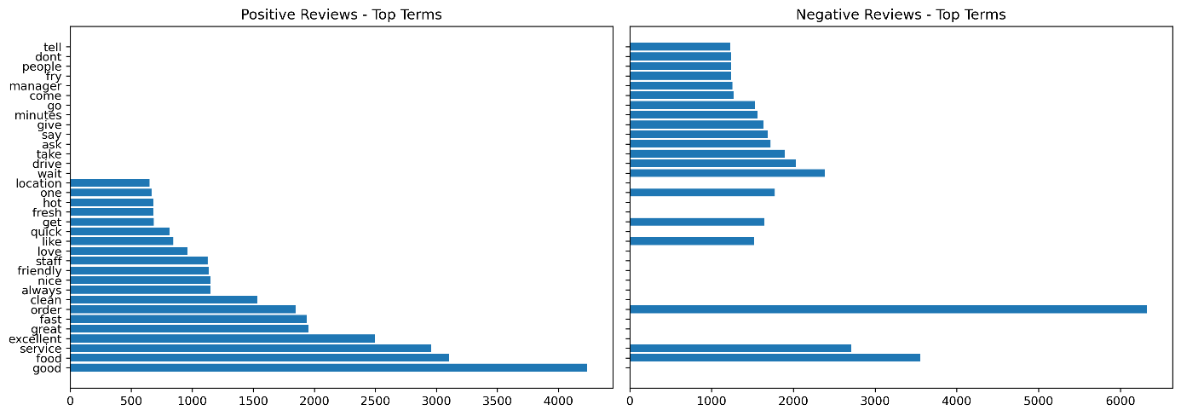
- view of the most influential words in the corpus by frequency
- positive words i.e. 'good', 'excellent', 'fast',
- negative words i.e. 'worst', 'rude', 'slow', 'wrong',
- neutral words which don't add sentient but are present in both positive and negative word lists i.e. 'food', 'service', 'order'
- sentiment appears to come from items such as ‘speed’, ‘cleanliness’, ‘staff behaviour’
- Confirms review data has valuable insight and is not random, and can build more sentiment analysis from it.
- 'food' and 'service' are the top occurring words in both positive and negative reviews, the key word alone will not indicate type of feedback, we need to star rating to apply that context.

- Identification of the most important variables
- High Analytical Value
  - 'reviewer_id' - our primary key, allows for unique reviewer per row data, prevents duplication and allows reviewer aggregation.
  - 'review' - contains actual review text. essential for further analysis and NLP tasks.
  - 'star_rating_num' - essential to provide context and sentiment for text review data.
  - 'store_id' - allows for review per store and comparisons between stores
These variables are retained in the dataframe as they are core to future analysis

- Limited Analytical value
  - 'review_relative_time' - derived time values, as such limited use for detailed proper time series analysis. Encountered issues around clustering of times around December, so accuracy is questionable outside of yearly time frame.
  - 'lattitude' and 'longitude' - potential value if can include soe spatial/geolocatin analysis.
  - 'city' - medium value to aggregate data by city
  - 'state' - medium value to aggregate data by state
These variables while they are not included in initial modelling dataframe in stage 3, they are available in case of future usage requirements

- Low Analytical value
  - 'store_address' - in its current form not a huge amount of analytical value. parsed it out into its constituent components which may have some value.
  - 'street_number - limited value as have 'store_id' as unique id for stores now. May provide some use later
  - 'street_name' - limited value as have 'store_id' as unique id for stores now. May provide some use later
  - 'country'- no analytical value. No variation in the data, just a single data value.
  - 'category' - no analytical value. No variation in the data.
  - 'store_name' - no analytical value. No variation in the data.
  - 'rating' - low analytical value now as mixed alphanumeric and have derived 'star_rating_num' column now.
  - 'review_time' - low analytical value now as mixed alphanumeric and have derived 'review_relative_time' column now.

These variables are removed from the dataframe o reduce noise and dimensions.

- Determination of how valuable columns was evidence based.
  - assessment of dtypes and variable meaning
  - numerical and categorical data exploration
  - quantity of data per column
  - variety of data (number of unique of values)
  - level of corruption present
  - missing values
  - plots and statistical analysis
  - where data wasn't clean, derived new columns were created which were more easily usable in analysis such as 'store_id' and 'star_rating_num'

3. Model Building and Evaluation (20 points)
- Details of Algorithms & Configurations
Part 1) Words most associated with review sentiment
Crate a more targeted corpus to allow determine sentiment. Have a more targeted corpus per pos and neg reviews is key to getting accurate results in our modelling. This step is essential.
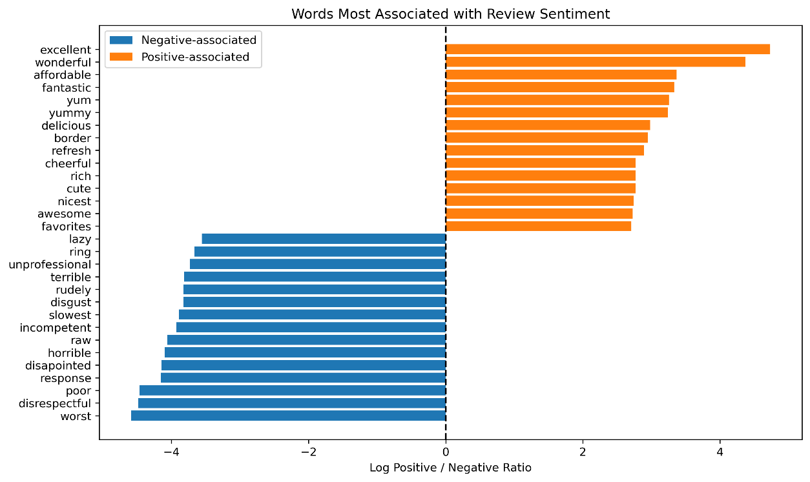
    - A log ratio analysis used to identify exclusively positive words and exclusively negative words
    - negative words drive complaints
    - positive words drive customer satisfaction
    - '4.5'to '0' = word appears in negative reviews. The higher the value the more associated with negative reviews the word is. This is a relative number
    - 0 = word appears equally in both positive and negative reviews i.e. 'food', 'order'
    - '0' to '4.5' = word appears in positive reviews. The higher the value the more associated with negative reviews the word is. This is a relative number
    - Some words imply specific actions such as staff behaviour, customer service, service times, food quality, cost
    - customer service or staff behaviour appears to be one of the biggest drivers of customer disastisfaction with words such as 'disrespectful', 'response', incompetent', 'slowest', 'rudely' , 'unprofessional', 'lazy' appearing strongly in the negative review words.
Part 2) Convert the data to binary sentiment analysis i.e. positive or negative 1 or 0
‘’’py
# keep only negative (1–2) and positive (4–5)
mask = y_raw != 3
X_texts = X_texts[mask]
y_raw = y_raw[mask]
# binary sentiment: 1 = positive (4–5), 0 = negative (1–2), 3 is removed
y = (y_raw >= 4).astype(int)
==== y value counts - class distribution =====
star_rating_num
1 16061
0 12516
Name: count, dtype: int64
==== y unique values =====

Unique labels: [0 1]
‘’’
    - 0 = negative reviews, which is 1 and 2 stars
    - 1 = positive reviews, which is 4 and 5 stars
    - 3 = neutral has been removed
    - binary values now present in dataset
- had 5 values in dataset, ratings 1 to 5, but changed to binary sentiment

Part 3) Model selection and configuration settings
All models used were liner classifiers, so they suit the dataset and we can compare
- Logistic regression
  - good for text classification and intepretability-
  - creates co-efficients per word which can check fi we need for a particular outcome
- Naïve Bayes
  - commonly used for word frequency data
  - standard probabilistic output
- Linear SVM
  - doesn't use probability modelling like others
  - output decision scores rather than probabilities
- GD Logistics
  - scalable linear model

Non linear models such as decision trees, Ramdon forest , Neural Networks etc have dependencies between features i.e. word A only matters if word B is present, and words can change sentiment depending on combination i.e. good service vs bad service for example. which is not present in our dataset, so these are not good candidates.

As they are also all linear models we also can compare easily and directly across the models.

Configuration
- Train/Test plit
- ‘test_size = 0.2’ (standard size – 80%/205 split. Did not modify)
- ‘stratify=y’ (preserves class ratio)
- ‘random_state =42’ (just a random value to ensure same start point each time (the answer to life...))
- text feature extraction
  - used tf-idf vectorization for all
  - used same values for all models to ensure consistency in results comparison
- ‘max_features=1000’ (limit dimensionality for speed)
- ‘min_df=5’ (removes very rare words (typos, on-off tokens etc)
- ‘max_df=0.7’ (removes very common terms appearing in > 70% of rows)
- Cross-validation
  - stratifiedKfold
    - ‘n_splits = 5’ (standard value for number of folds. Did not modify)
    - ‘shuffle = true’

- Model Performance Metrics & Evaluation of Results
Present the performance metrics used to evaluate the models. Compare the results, highlighting the strengths and weaknesses of each model.

4. Advanced Techniques and Analysis (20 points)
- Advanced text-mining techniques applied to the dataset
Describe any advanced techniques beyond basic modeling applied to the dataset.
- Comparison with other Research & Reflections
Compare your results to at least three other researchers (maximum of five) who used the same data set. What lessons did you learn from doing this? How can your work be improved? Did you include any improvements in your work and what impact did it have?

5. List of Insights, Recommendations, and Future Works (20 points)
- Conclusions of the Study
Summarise the key findings and conclusions derived from your analysis.
- Action Plan for Business Strategy Enhancement
Provide specific recommendations based on the data analysis, including a detailed action plan on how these recommendations can be applied to improve the business strategy.
- Consideration of Social Implications
Discuss the social implications of the proposed actions, ensuring that the recommendations align with ethical standards and contribute positively to the broader community.
- Future Work
Suggest potential areas for future research and development that can build upon the findings of this study.

References (if possible with APA format)
Use one of the commonly used References and Citation formats.

